Aggregate Volatility Model Results

For the

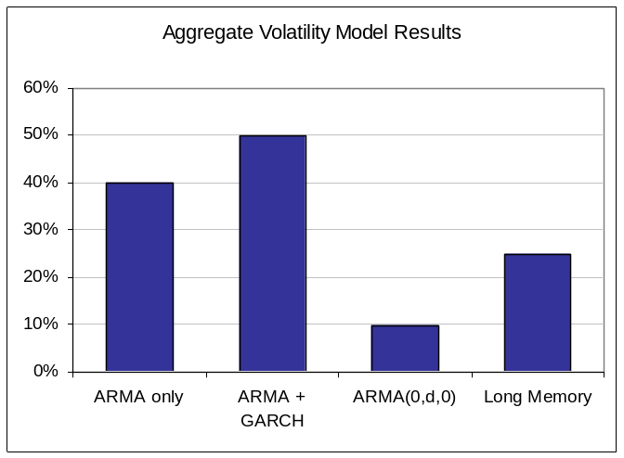
Figure IV.1: Aggregate Volatility Model Results Across States

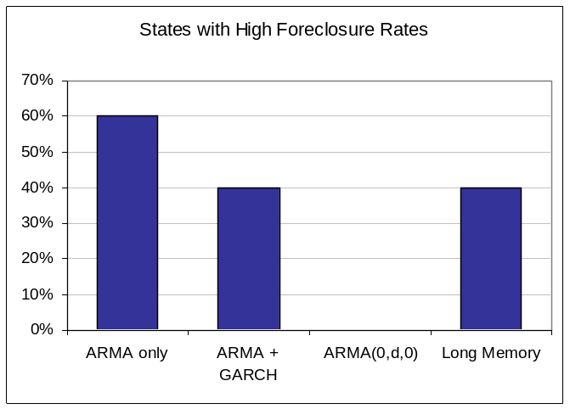
Figure IV.2: Volatility Model Results for States with High Foreclosure Rates

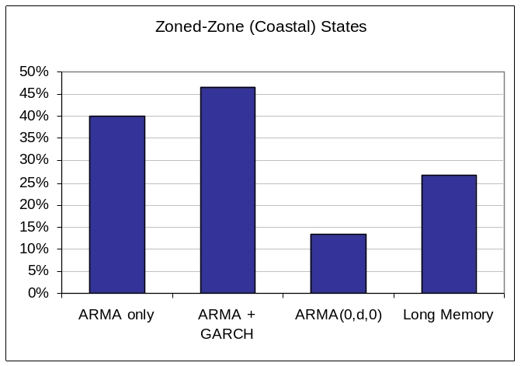
Figure IV.3: Volatility Model Results for Zoned-Zone Coastal States

